NIST PF Compliance for Log360
Strengthen data protection and meet NIST PF compliance with Log360.
Region: USA | Type: Data Privacy, Industry Standard, Incident Management | Category: Compliance | Pricing: Free

Overview
The NIST PF compliance extension in Log360 helps organizations meet the NIST Privacy Framework: A Tool for Improving Privacy through Enterprise Risk Management, a voluntary NIST framework for managing privacy risks and protecting individuals' personal data by providing centralized log management, real-time user activity monitoring, and privacy incident detection. The platform supports NIST PF requirements for data inventory management, access control, privacy risk assessment, privileged access governance, audit logging, incident response, and data protection.
For Privacy Risk Identification and Data Inventory, Log360 tracks user file access and system events, enabling visibility into data flows and supporting the Identify-P function's requirement for data mapping and risk discovery. To address Access Control and Data Minimization, the platform monitors user logon activity, failed access attempts, and AD group memberships to enforce least-privilege access and detect unauthorized access to personal information. The extension also supports Privacy Governance and Policy Accountability by providing capabilities that audits policy changes, group membership modifications, and GPO configurations to ensure governance controls are in place and effective across the organization.

Key Features
- Privileged Access and Identity Management: Log360 monitors privileged account activity, SUDO command usage, role assignments, and password changes to control access to personal data repositories.
- Audit Logging and Continuous Monitoring: Log360 collects and correlates event logs, system events, and process tracking data to provide comprehensive audit trails supporting ongoing privacy oversight.
- Privacy Incident Detection and Response: Log360 monitors network attack events, Windows threat detection, malware alerts, and firewall violations to identify and respond to potential privacy breaches in real time.
- Data Protection and Removable Media Controls: Log360 audits USB storage events, file modifications, and cloud storage activities to prevent unauthorized exfiltration of personal information.
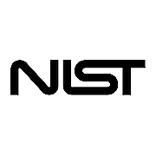
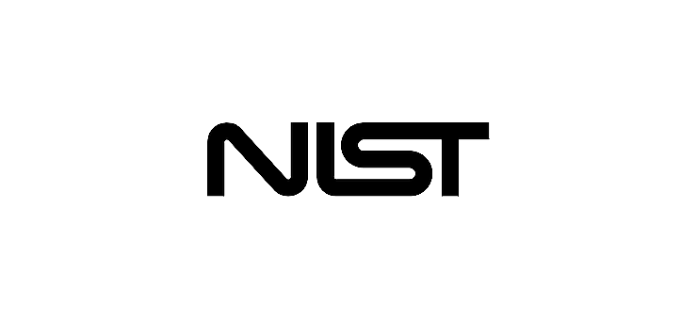
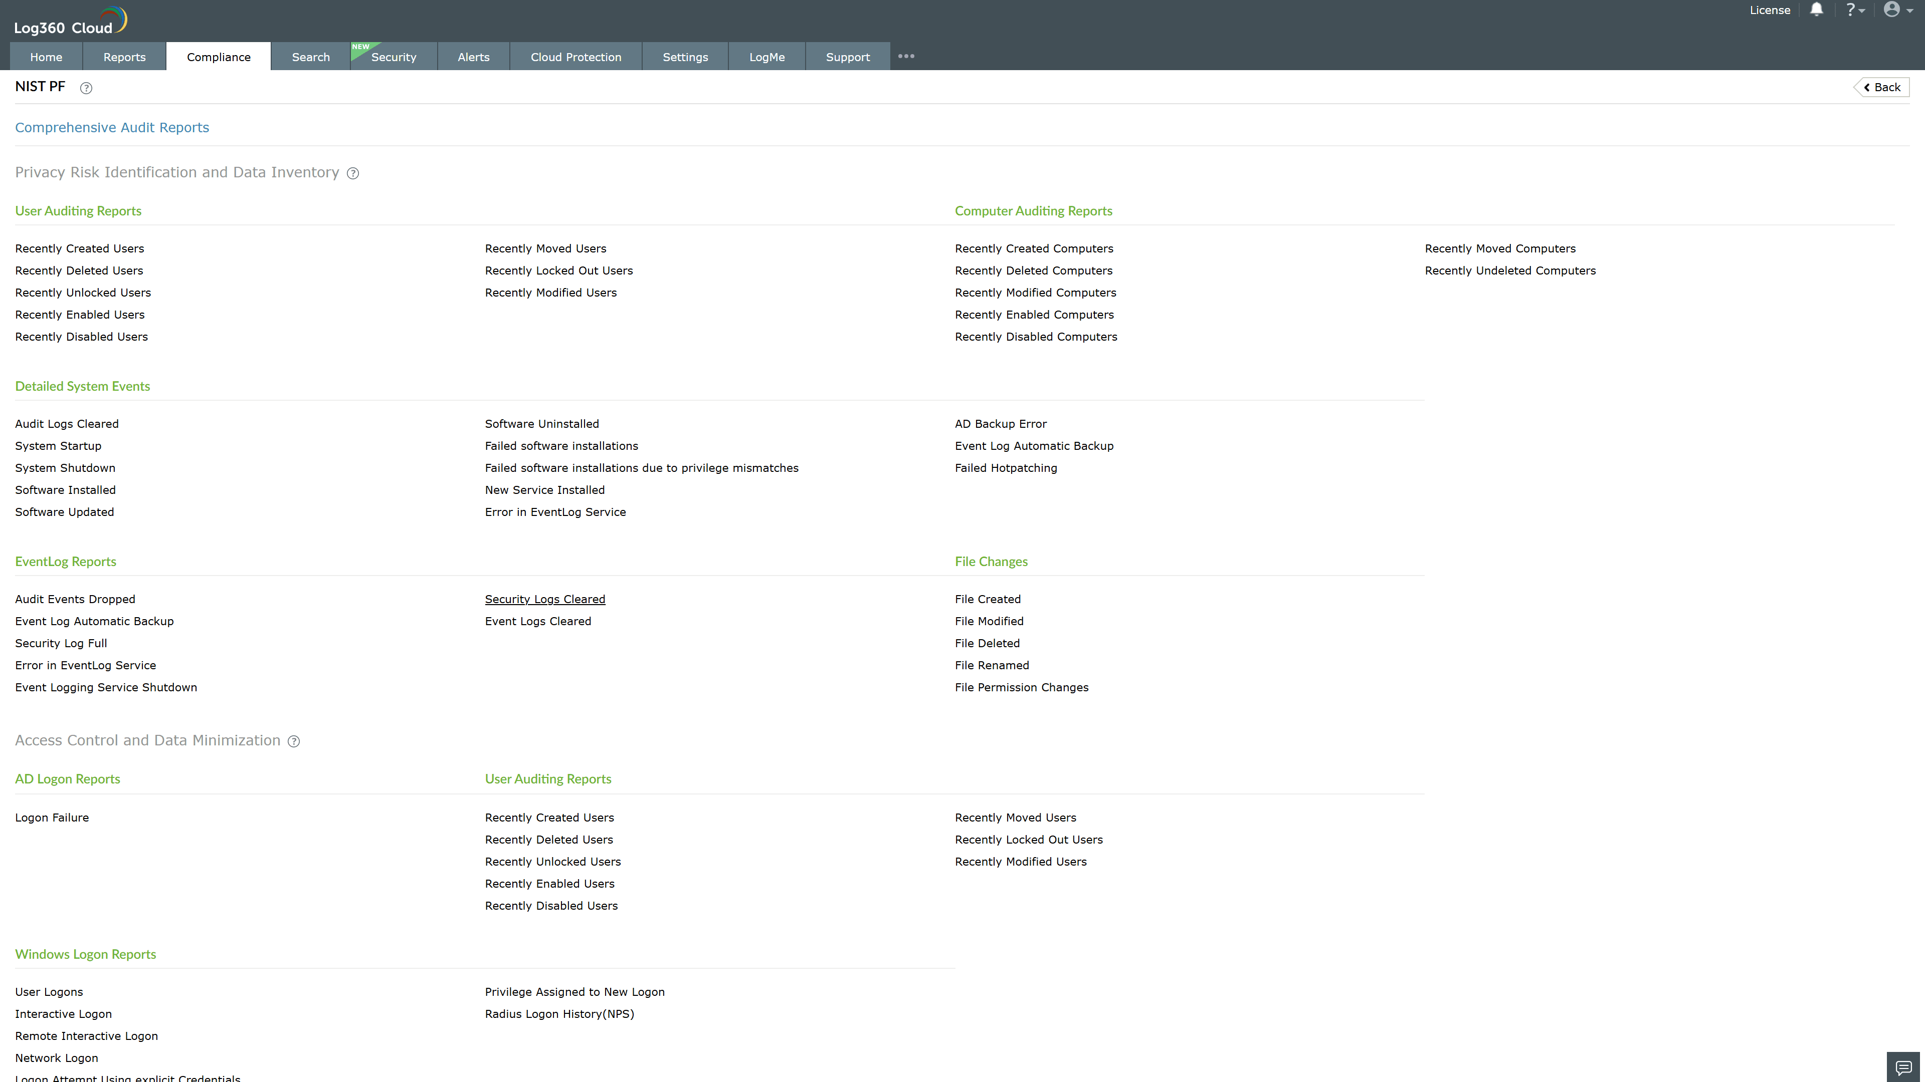
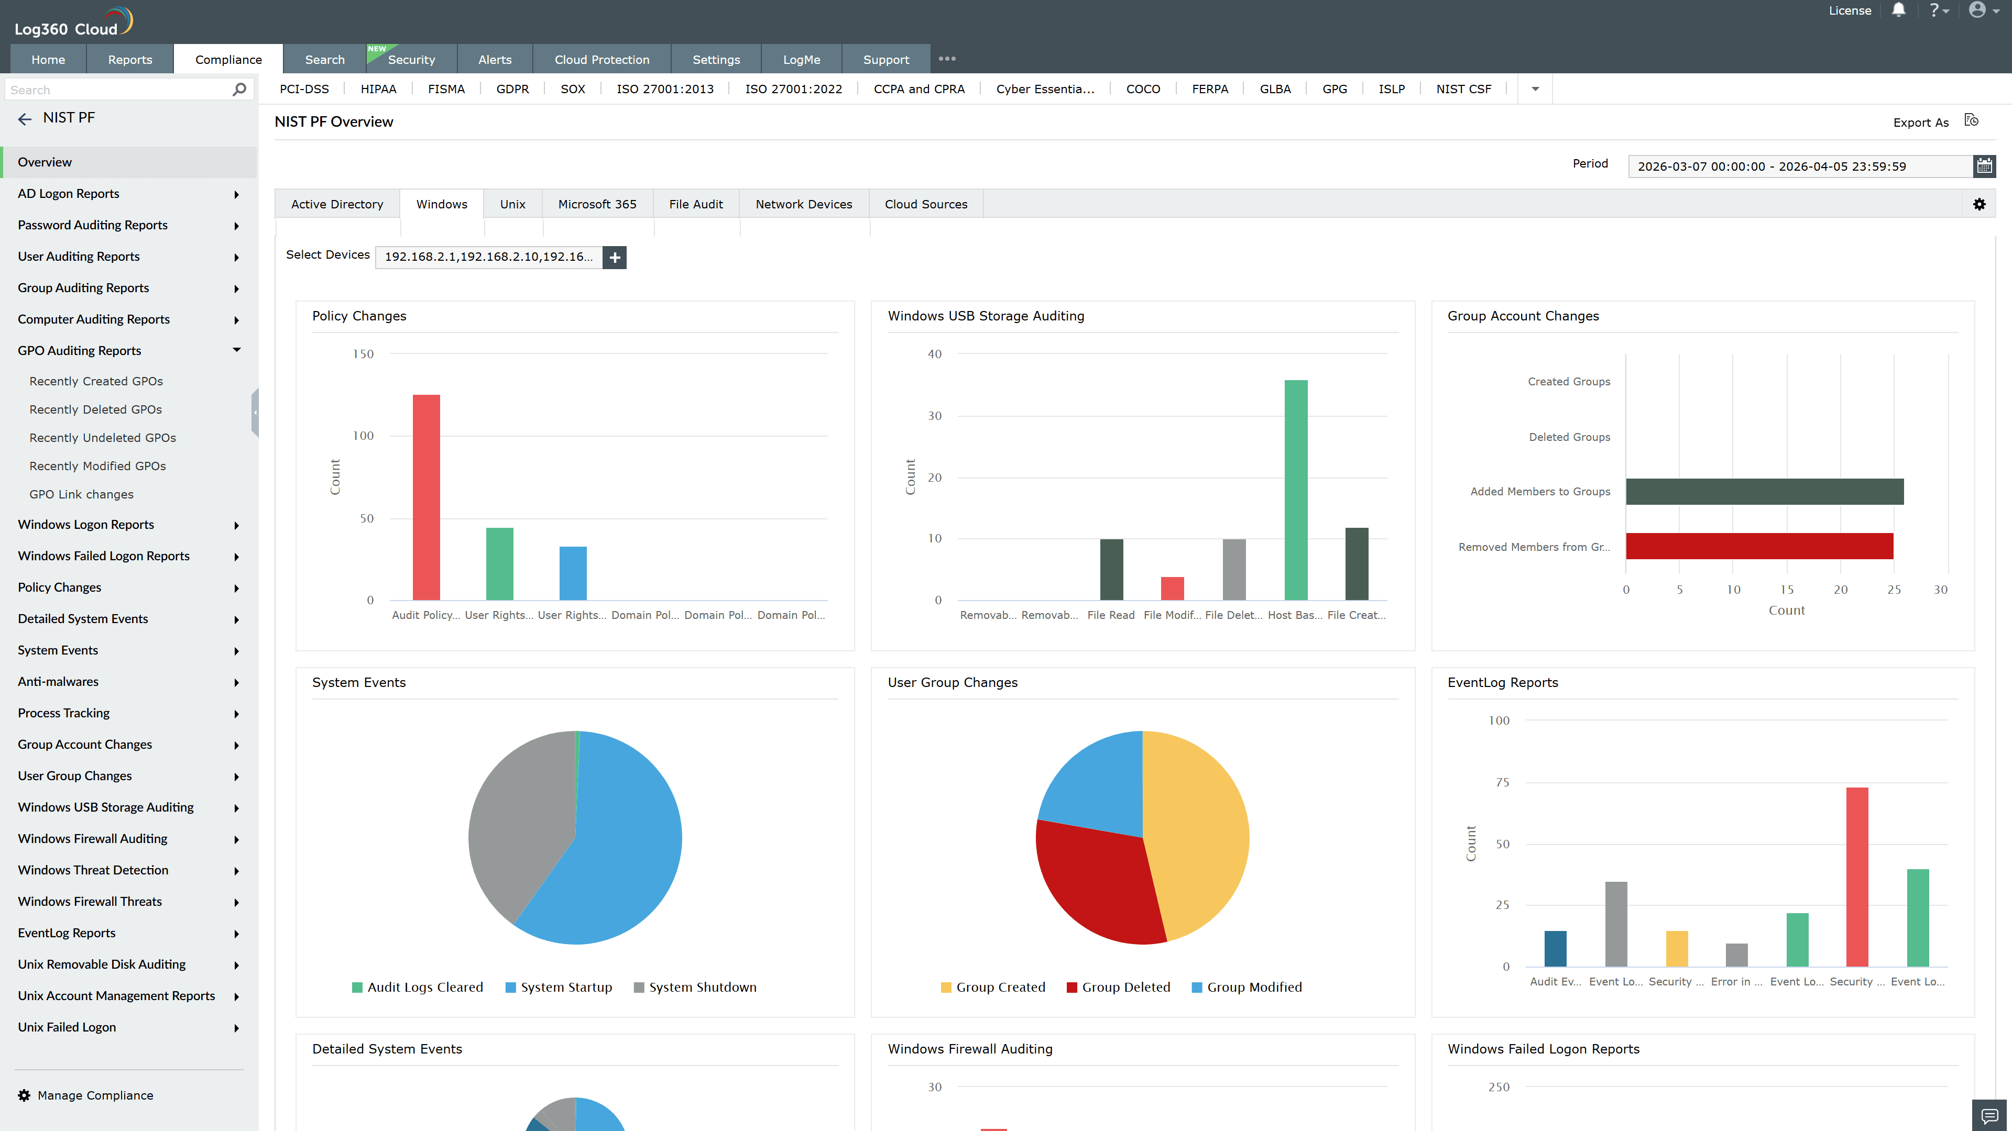
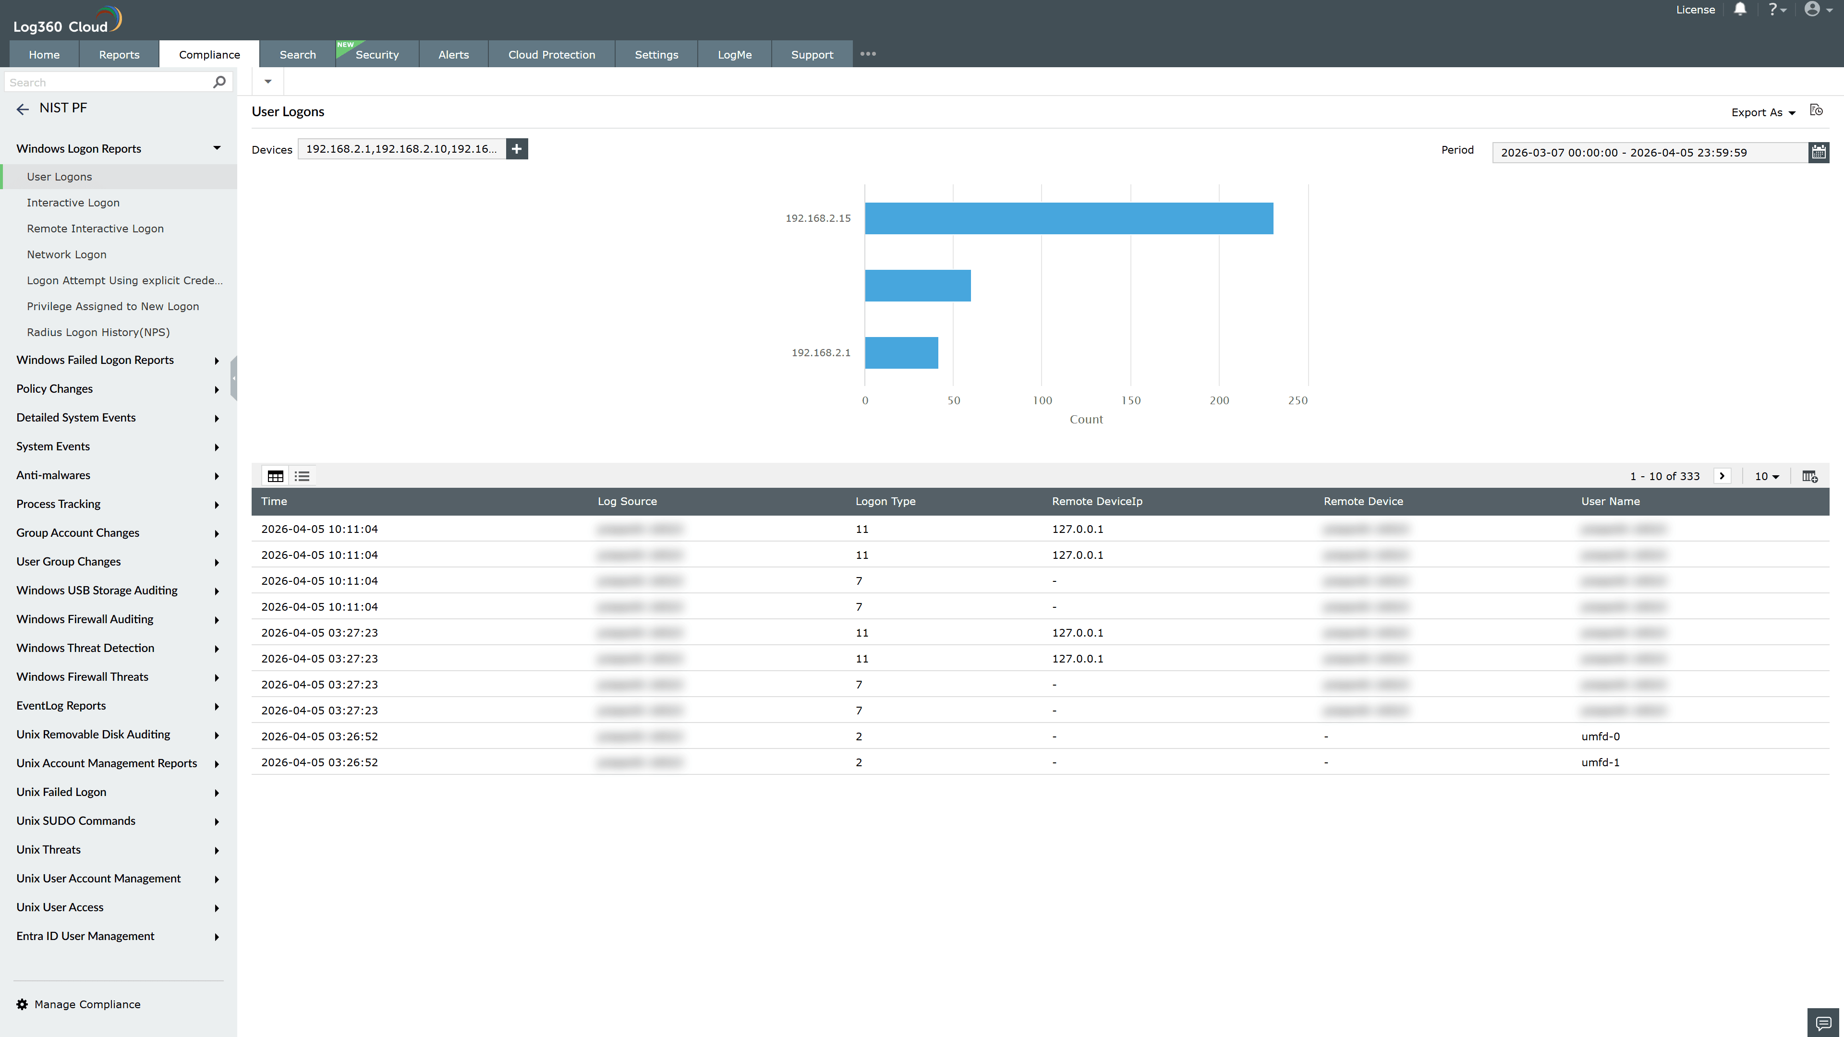
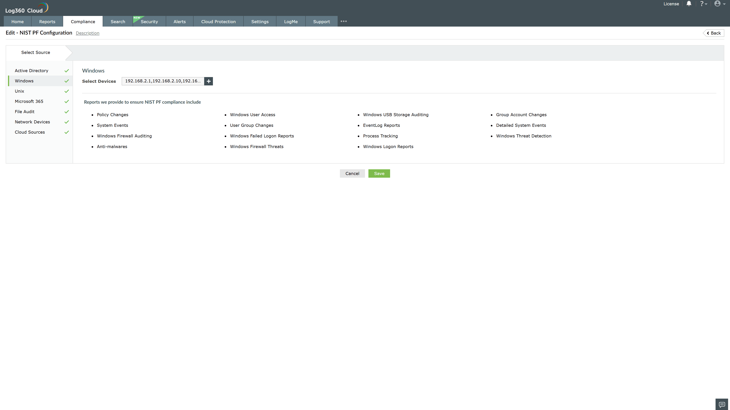
Valid Submission : Yes
Supported Editions : Free, Basic, Standard, Professional, MSSP
Help Document : https://www.manageengine.com/log-management/help/integrations/compliance-extensions.html
Help Video : Not provided
Tags : Log360, Compliance, Privacy monitoring, Data privacy, Regulatory compliance
Supported DCs : US, IN, JP, CA, AU, UK and EU
Privacy Policy:
Terms of Service:
Release Notes:
Predefined reports for the NIST PF.

